Diameter Chord
# Source: AI Source: Provided by: [Data Path: Persons Table -> ID Column: 1, Name_En Column: Motasem Essam] -> From: [ChatGPT] on [7/25/2026]
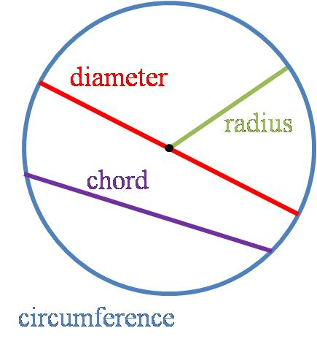
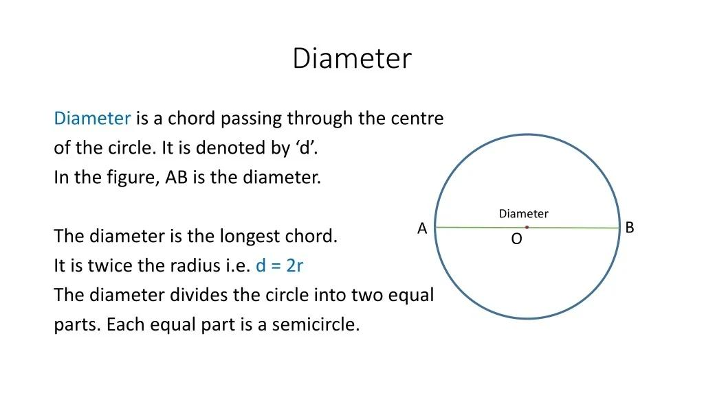
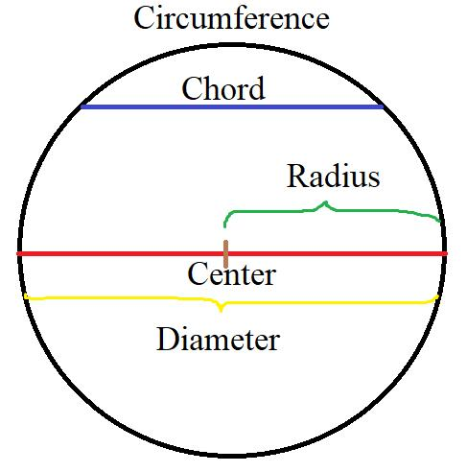
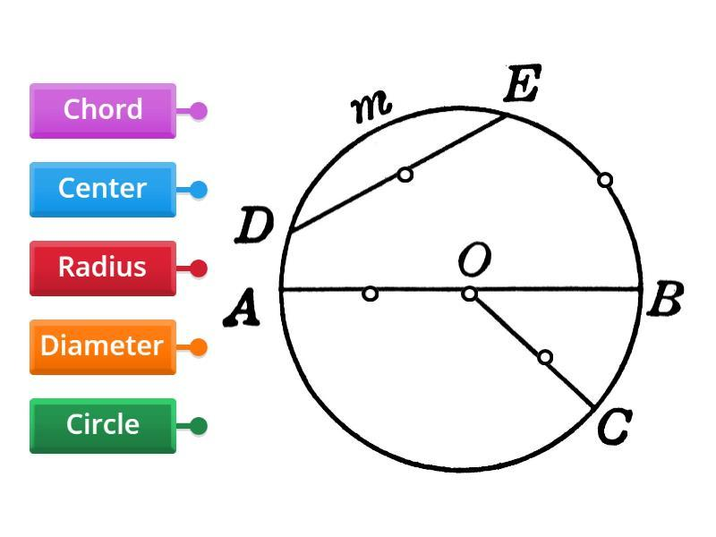
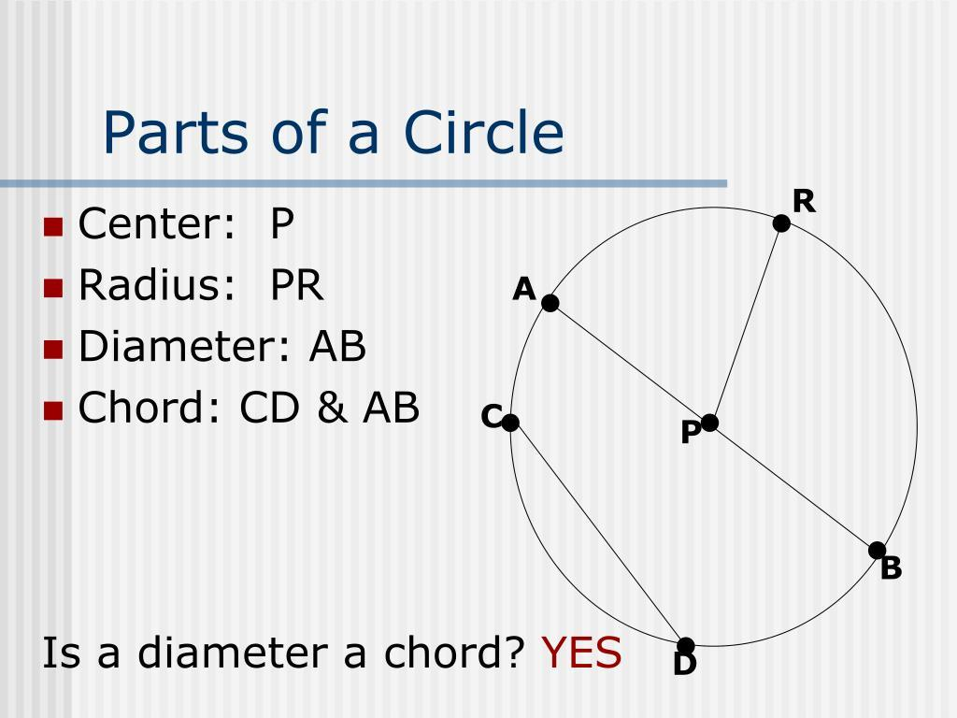

Definition
# Source: AI Source: Provided by: [Data Path: Persons Table -> ID Column: 1, Name_En Column: Motasem Essam] -> From: [ChatGPT] on [7/25/2026]
A Diameter Chord is a chord that passes through the center of a circle.
Because a diameter has both endpoints on the circumference and passes through the center, every diameter is a chord.
$$\boxed{\text{Diameter Chord}=\text{Chord passing through the center}}$$
The term diameter chord is descriptive; mathematically, the segment is simply called a diameter.

Fundamental Elements
# Source: AI Source: Provided by: [Data Path: Persons Table -> ID Column: 1, Name_En Column: Motasem Essam] -> From: [ChatGPT] on [7/25/2026]
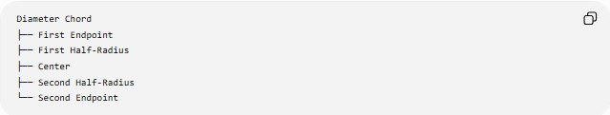
Diameter Chord
├── First Endpoint
├── First Half-Radius
├── Center
├── Second Half-Radius
└── Second Endpoint
If $A$and $B$are points on the circumference and $O$is the center:
$$A-O-B$$
then:
$$\overset{‾}{AB}$$
is a diameter chord.
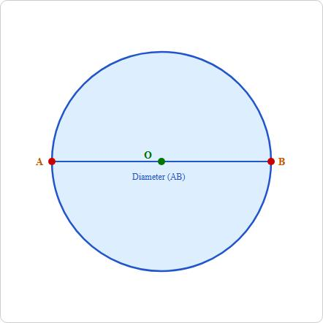
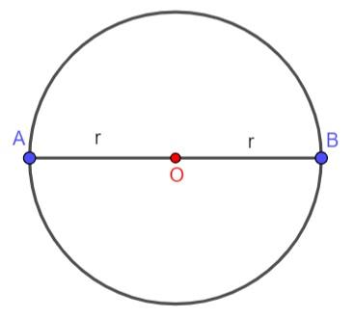
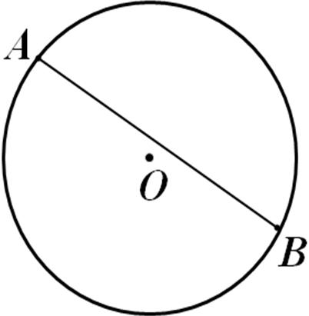
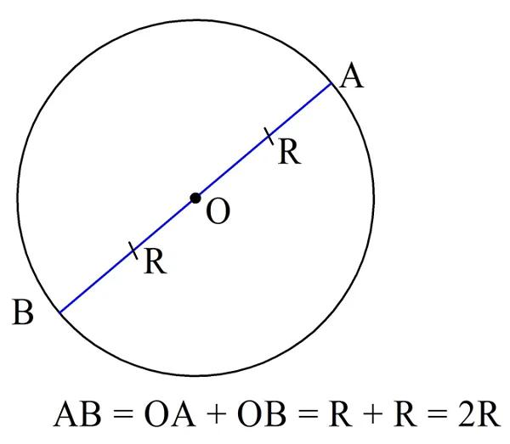
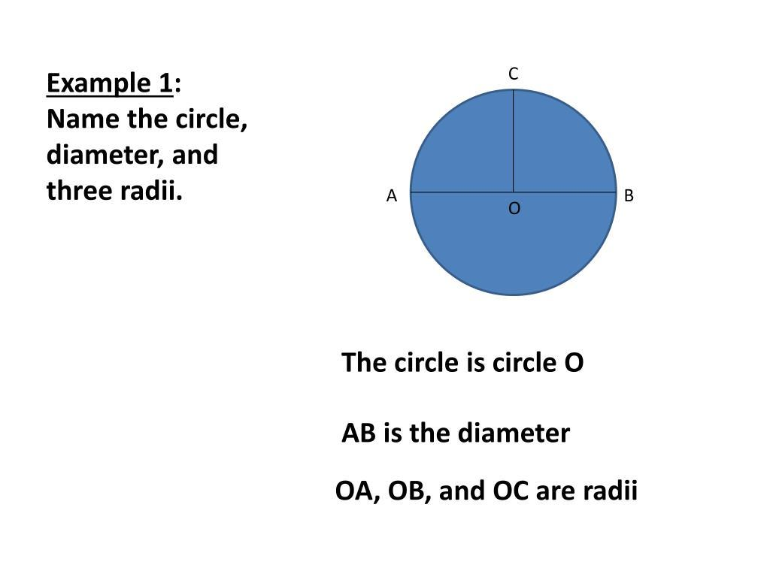

Main Properties
# Source: AI Source: Provided by: [Data Path: Persons Table -> ID Column: 1, Name_En Column: Motasem Essam] -> From: [ChatGPT] on [7/25/2026]
1. Passes Through the Center
The defining property is:
$$\boxed{O∈\overset{‾}{AB}}$$
where $O$is the center.
2. It Is the Longest Chord
Among all chords of a circle, the diameter has the greatest length.
$$\boxed{d≥L}$$
for every chord length $L$.
3. It Contains Two Radii
A diameter consists of two radii placed end-to-end:
$$\boxed{d=2r}$$
4. It Divides the Circle into Two Semicircles
Every diameter divides the circle into two equal semicircles.
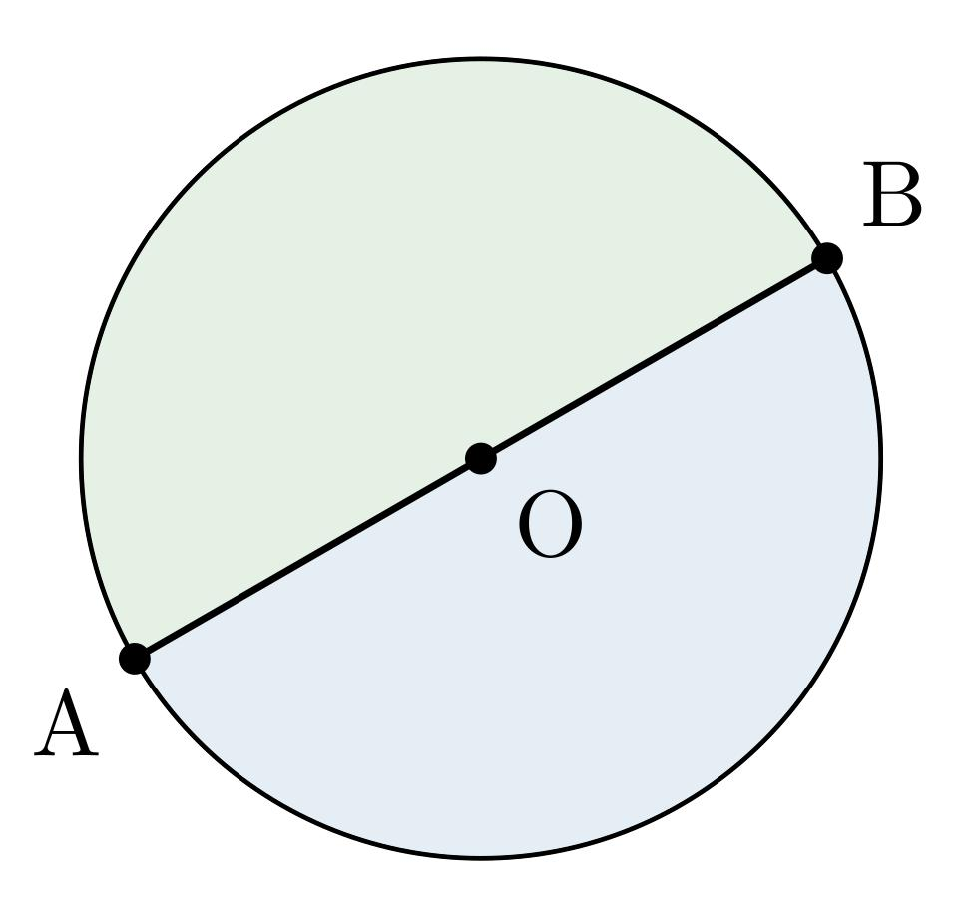
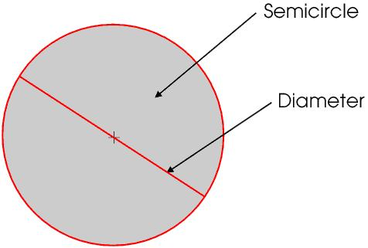
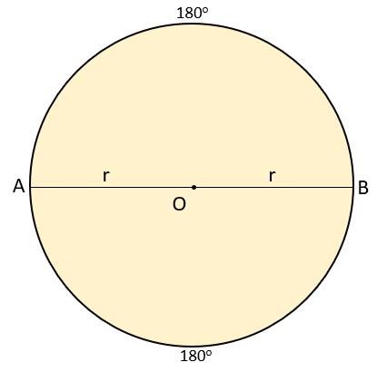
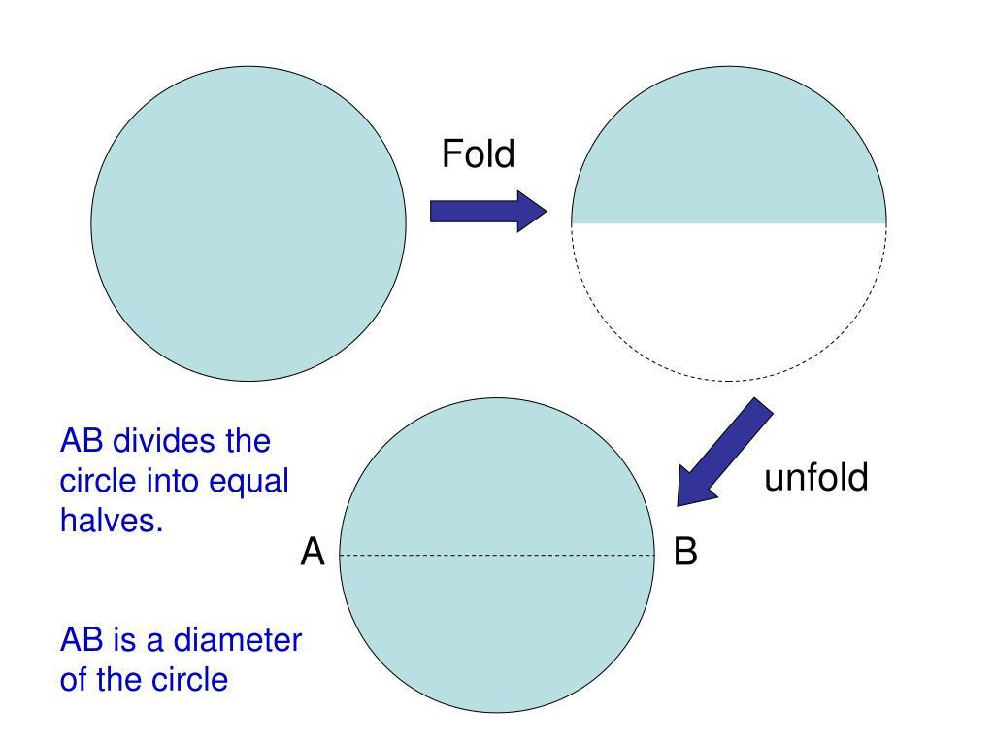
5. Infinitely Many Diameter Chords
A circle has infinitely many diameters because a diameter can be drawn through the center in any direction.

Diameter Chord vs Other Chords
# Source: AI Source: Provided by: [Data Path: Persons Table -> ID Column: 1, Name_En Column: Motasem Essam] -> From: [ChatGPT] on [7/25/2026]
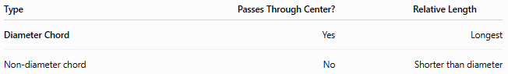
Type | Passes Through Center? | Relative Length
Diameter Chord | Yes | Longest
Non-diameter chord | No | Shorter than diameter
The closer a chord is to the center, the longer it is. A chord becomes longest when its distance from the center is zero—that is, when it becomes a diameter.
Diameter Chord and Perpendicular Bisector
A diameter perpendicular to another chord bisects that chord.
If $AB$is a chord and $CD$is a diameter such that:
$$CD⊥AB$$
then the diameter bisects $AB$.
$$\boxed{AE=EB}$$
where $E$is the intersection point.
Diameter Chord and Angle
An angle subtended by a diameter at a point on the circumference is a right angle.
$$\boxed{∠ACB={90}^{∘}}$$
This is the angle in a semicircle theorem (Thales' theorem).
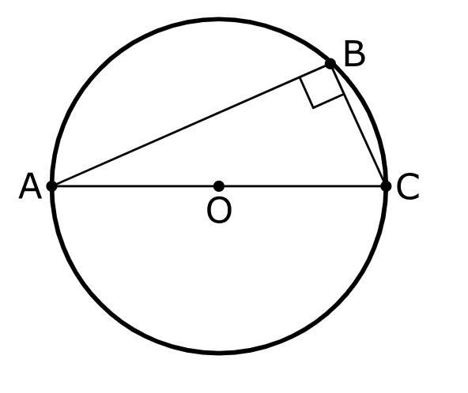
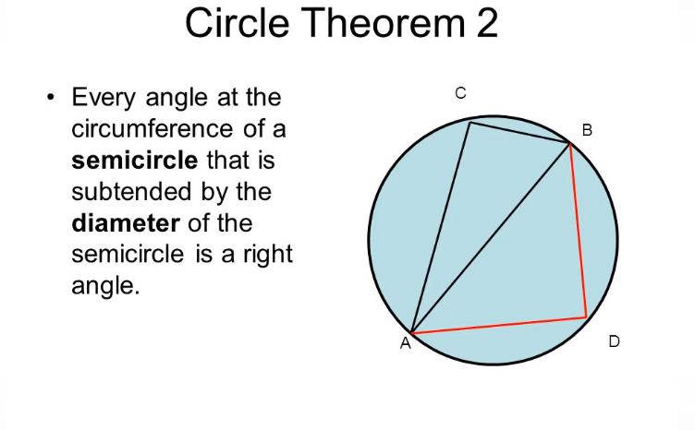
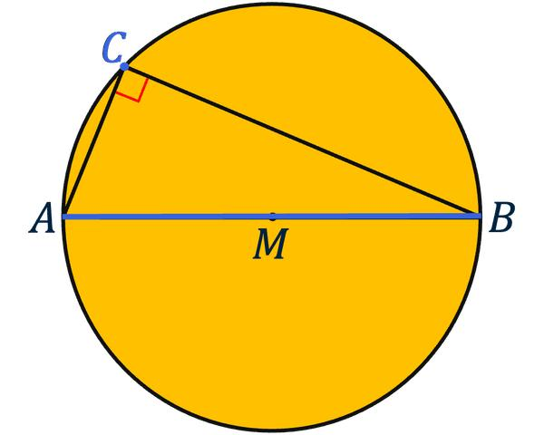
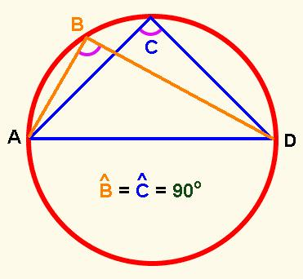

Mathematical Relationships
# Source: AI Source: Provided by: [Data Path: Persons Table -> ID Column: 1, Name_En Column: Motasem Essam] -> From: [ChatGPT] on [7/25/2026]
Diameter and Radius
$$\boxed{d=2r}$$
Circumference
$$\boxed{C=πd}$$
Area
$$\boxed{A=\frac{πd^{2}}{4}}$$
Chord Length
For a chord at distance $h$from the center:
$$L=2\sqrt{r^{2}-h^{2}}$$
For a diameter:
$$h=0$$
so:
$$L=2\sqrt{r^{2}}=2r=d$$
Thus the diameter is the maximum possible chord length.

Classification
# Source: AI Source: Provided by: [Data Path: Persons Table -> ID Column: 1, Name_En Column: Motasem Essam] -> From: [ChatGPT] on [7/25/2026]
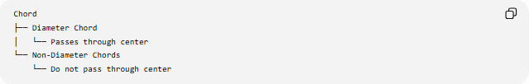
Chord
├── Diameter Chord
│ └── Passes through center
└── Non-Diameter Chords
└── Do not pass through center

Example
# Source: AI Source: Provided by: [Data Path: Persons Table -> ID Column: 1, Name_En Column: Motasem Essam] -> From: [ChatGPT] on [7/25/2026]
A circle has radius:
$$r=6\text{ cm}$$
Its diameter chord has length:
$$d=2r \\ d=2\left(6\right)=\boxed{12\text{ cm}}$$
Any other chord of this circle must have a length less than or equal to $12\text{ cm}$.

Key Points
# Source: AI Source: Provided by: [Data Path: Persons Table -> ID Column: 1, Name_En Column: Motasem Essam] -> From: [ChatGPT] on [7/25/2026]
- A diameter chord passes through the center.
- It is technically called a diameter.
- Every diameter is a chord.
- It is the longest chord of a circle.
- It consists of two radii.
- It divides the circle into two equal semicircles.
$$\boxed{\text{Diameter Chord}=\text{Longest Chord}=\text{Diameter}}$$

